Property name:- Me:nam Homestay (Majuli)

Stay Type;- HomeStay
Max Capacity :- 30 Person
Price :- 3500rs

Location :- https://www.google.com/maps/place/Me:nam+Homestay+(Majuli)/@27.0602567,94.2634877,19z/data=!4m6!3m5!1s0x3746d37af305cd35:0xdcb446aaa197a5d8!8m2!3d27.0602567!4d94.2639478!16s%2Fg%2F11k4rvzf23?hl=en&entry=ttu&g_ep=EgoyMDI0MTEwNi4wIKXMDSoASAFQAw%3D%3D

Address:- Jengrai Chapori Rd, Kesaikhua gaon, Moghua Chuk, Assam 785105

Amanites:-
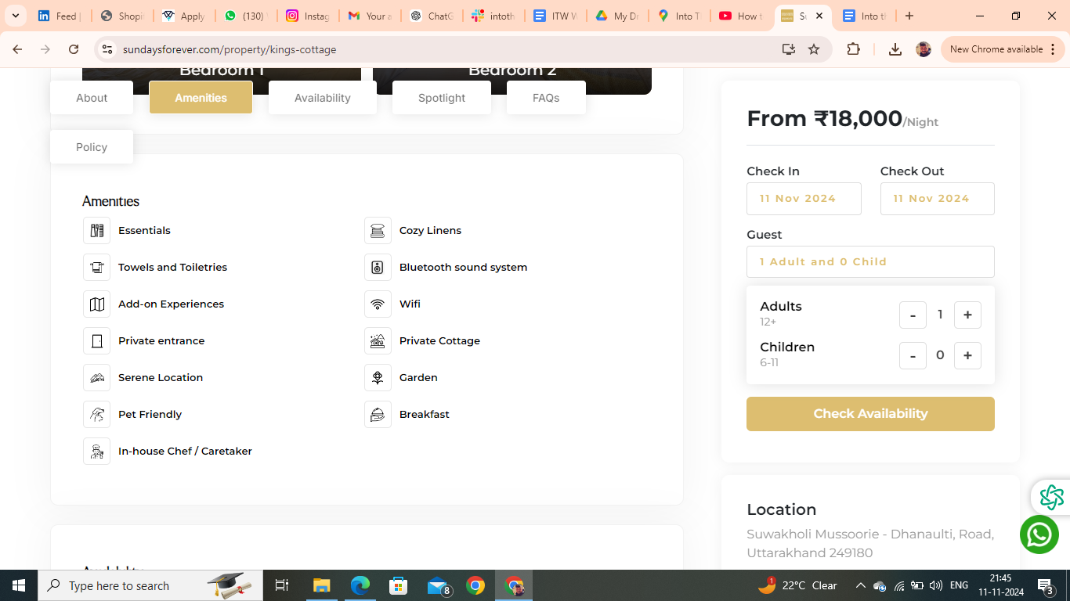

Amanites you have to remove are :- Essentials, Bluetooth Sound System, Towel, Private entrance, Patio & balocny

FAQs

Is Driver and/or House-Help accommodation available?
Driver accommodation depends upon the first come first serve basis. It is available at nominal charges a small room or Bunk bed with dinner and breakfast will be provided just nearby the property.

Is parking available onsite or nearby?
Free parking is available onsite. There is ample car parking for 4-5 cars at the site.

Is the Property suitable for a day picnic?
Yes, the home has a garden/lawn area within the premises that could be used for outdoor picnic activities. Meals will be provided on site at an additional charge (per person, per meal).

Is property pet friendly?
We’re happy to welcome your furry friends at Me:nam Homestay! Please bring a pet bed along, as pets aren’t allowed on guest beds or any linen. Enjoy a comfortable stay for you and your pet in the heart of nature!

Booking Policies
House rules
- Check-in: 2 PM Check-out: 10 AM
- Guest are requested to shut the windows and doors during the evening . as the property may be prone to insect and bug.
- Guest are not allowed to spill food or drinks over the upholstery or they will be charged at the time of checkout.
- Please Be mindful and keep the noise to the minimum after 10 pm.
- Passport, Aadhar, Driving License and Govt. ID are accepted as ID proof(s)
- Allows private parties or events
Refund & Rescheduling Policy
- Refund would be processed in 14 working days .
- Booking can be rescheduled till 15 days prior to arrival date depending upon the availability.
- Rs1000 plus applicable taxes will be charged for rescheduling .
- Rescheduling can be done only for the same property.
- If the tariff on the rescheduled date is higher than the initial booking date then the difference is payable.
Things you need to know
- The full payment must be made for your booking to be confirmed
- Only the guest who have been accounted for are allowed at the Property
- Any damage to the property caused by the guest will be charged as per the actual cost of repair or replacement.
- Any commercial activity is strictly not permitted.
- Guests are earnestly requested to treat the home with care.
- Any damage to the property caused by the guest will be charged as per the actual cost of repair or replacement.
- Consider this as a homestay in mountains not a Typical Hotel Stay
Cancellation and Refund Policy
- Cancellation 12 days prior to arrival date 15 % will be charged.
- Cancellation 07 days prior to arrival date 50 % will be charged.
- Cancellation less than a week full retention would be applicable.
- Credit/Debit card cancellation will be charged 5 % extra.
- Cancellation policy for long weekends and special days .
- Cancellation 07 days prior to arrival date 50 % will be charged .
- Cancellation less than a week full retention would be applicable.

Description:-
Welcome to Me:nam Homestay, nestled on Majuli Island, the world’s largest river island and a cultural treasure in Assam. Run by the owner herself, this homestay offers a warm, local touch, giving guests an unforgettable experience. From meeting locals to exploring traditional crafts and customs.

Me:nam Homestay is your gateway to the authentic heart of Majuli—an island rich in natural beauty, vibrant festivals, and deep-rooted traditions.

Things to Do at Me:nam Homestay
- Boating: Glide along the serene Brahmaputra River.
- Mask Making: Discover Majuli’s traditional art of handmade masks.
- Pottery Village: Visit local artisans crafting pottery by hand.
- Apong Making: Learn to make Apong, Assam’s unique rice beer.
- Weaving: Watch intricate weaving techniques by local craftsmen.
- Village Walk: Stroll through picturesque villages, meeting locals and experiencing daily life.

